Ombudsman Quarterly Review – Summer 2023

Production note
In this version of the Ombudsman Quarterly Review some images, which were used for decorative purposes, have been left out.

From the Chief Ombudsman
Perception is everything when it comes to reputation.
The recently released 2022 Transparency International Corruption Perceptions Index has New Zealand sitting at second equal with Finland on 87 points, three points behind Denmark who takes out the top spot shared by New Zealand, Finland and Denmark the previous year.
That New Zealand has maintained its position as either first or second for a decade is testament to our commitment to being a transparent and honest democracy. However, this year’s result is a drop from last year’s and, according to Transparency International, New Zealand’s lower score this year is a result of a gradual decline in our score in three of the eight component indexes that contribute to our ranking. That should be of concern.
These three indexes all survey both international and domestic business leaders about their experiences with public service corruption - that is to say, the results are based on expert perceptions of public sector and judicial corruption.
While New Zealand remains among the least corrupt countries in the world, this drop from first place shows we must guard against any influences that impact on the perception of New Zealand as a corruption-free country.
My office plays a crucial role in maintaining our open and transparent democracy, providing a watch on government thanks to laws like the Official Information Act, Local Government Official Information and Meetings Act, the Ombudsmen Act and the Protected Disclosures Act.
We live in a world where opinion can pass as fact and misinformation can easily spread. Now, more than ever, we need a public service, judiciary and government beyond reproach. As one of Parliament’s integrity oversight agencies, I am committed to ensuring I am doing my part in the year ahead.
Ngā mihi
Peter Boshier, Chief Ombudsman

Investigations

MBIE acted 'unreasonably' over managed isolation allocation system - Chief Ombudsman
The Chief Ombudsman says the Ministry of Business, Innovation and Employment’s advice to government ministers on the Managed Isolation Allocation System did not adequately take into account the very real impact it would have on people’s lives.
Peter Boshier released the findings of his investigation into the Managed Isolation Allocation System (MIAS) after receiving hundreds of complaints.

Chief Ombudsman initiates probe into OIA delays
Following on from his investigation into the OIA practices of 12 government agencies which resulted in the report called Ready or not?, the Chief Ombudsman has announced a related inquiry looking into the issue of how long it takes agencies to respond to requests for information.
Mr Boshier wants to know whether individual complaints about delays signals a broader issue.
Read the media release
Read the terms of reference

Children in Care
Broadened mandate for children in care imminent
The Chief Ombudsman is preparing for the enactment of the Oversight of Oranga Tamariki System Act later this year which gives the Chief Ombudsman an enhanced ability to consider complaints and monitor and investigate systemic issues.
Peter Boshier and his staff are currently connecting with groups that will be affected by the changes in the law, many of them non-government organisations. Engagement with tangata whenua is also underway to ensure that oversight is tikanga-informed to achieve better outcomes for tamariki, rangatahi, their family and whānau.

Case Notes

School board failed to follow due process when excluding a student
The Chief Ombudsman has found that a school board’s decision to exclude a student was unreasonable despite the fact the incident in question met the statutory test for gross misconduct.
The student was initially suspended for bringing alcohol to school and sharing it with another student. Prior to this incident, there had been various concerns about the student’s behaviour including swearing, being disruptive and unexplained absences.
As required by law, the board met to consider the suspension before excluding the student from school.
Overall, while the finding of gross misconduct was justified, Peter Boshier considered that the board omitted to consider the wider context of the student’s
behaviour and did not consider whether there was more that the board could have done to support the student.
Read the news article
Omission by school board to follow due process before excluding student for gross misconduct

Determination of ineligibility for publicly funded healthcare was wrong
The Chief Ombudsman found in favour of a visa-holder who was charged $23,000 for healthcare in New Zealand because they were considered one day short of the two years required to be eligible for publicly funded healthcare.
Mr Boshier found the Ministry of Health approach was wrong and the calculation should have been done by counting the days the person had been in the country – a number which means they were eligible.
The Ministry agreed to refund the amount already paid, apologise to the complainant and adopt a new method of calculating eligibility.
Determination of ineligibility for publicly funded healthcare was wrong

Exercise of discretion to refuse request for personal information not unreasonable
A complainant made a request for information about themselves that they believed had been provided to Inland Revenue (IR) by a third party. Inland Revenue provided a summary of the information it had received but refused to provide a full copy of the information, or details of who provided it, under section 18 of the Tax Administration Act 1994 (TAA).
The Chief Ombudsman investigated the IR Commissioner’s exercise of discretion and found the decision was not unreasonable.
Exercise of discretion to refuse request for personal information not unreasonable

Publications

Waka Tangata
The latest news and views from integrity organisations in the Pacific and Australasia is out and covers a wide range of initiatives, reports and updates.
The December 2022 edition includes contributions from the Office of the Ombudsman, Hong Kong, updates from our Australian counterparts and an interesting new initiative from Tonga that aims to make access to services of the Tonga Office of the Ombudsman more accessible for people in remote areas.
Read the full publication
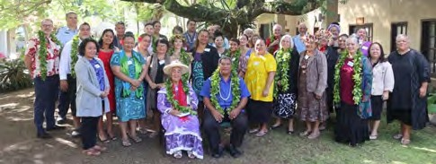
Participants in the Cook Islands National Human Rights Institute Stakeholder Dialogue

Architect of the Official Information Act looks back
Former National Cabinet Minister Sir Jim McLay, an early advocate of access to official information, gave his recollections on the passing of the Official information Bill to the House on July 23, 1981.
Read the article

International

Chief Ombudsman’s Tonga visit
Peter Boshier recently had the honour and rare privilege of being invited to address a special session of the Legislative Assembly of Tonga. The address was part of a visit to farewell retiring Tongan Ombudsman ‘Aisea Taumoepeau who served nearly nine years in the role.
Mr Boshier’s speech traversed a range of topics including the role that an Ombudsman brings to a country's integrity structure.
This theme was also a part of his formal recognition of the outgoing Ombudsman’s significant contribution to the Tonga Office of the Ombudsman and the wider Pacific Ombudsman community. Mr Boshier says “Aisea Taumoepeau has done an excellent job upholding the principles that underpin this important role.”
His visit to Tonga was also an important opportunity to support and strengthen the long-standing relationship with Tonga’s Office of the Ombudsman and engage with other stakeholders and institutions.
Tonga and New Zealand are active members of the Australasian and Pacific Ombudsman Region (APOR).
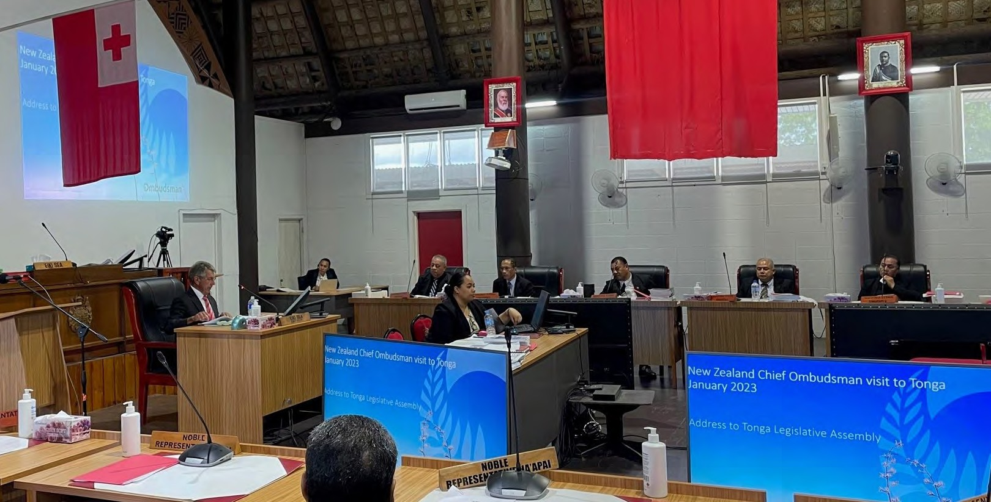
Peter Boshier addressing a special session of the Legislative Assembly of Tonga.

OIA’s 40th anniversary noted by Independent Information Access Commissioners and Ombudsmen of Australia & New Zealand
The Chief Ombudsman recently hosted Independent Information Access Commissioners and Ombudsmen of Australia and New Zealand who gathered in Wellington late last year to celebrate the 40th anniversary of the Official Information Act and the passing of information access laws in Australia.
At the conclusion of the meeting, members adopted a Communiqué noting that the event marked 40 years since both Australia and New Zealand introduced what was then considered game-changing legislation.
Read the full Communiqué
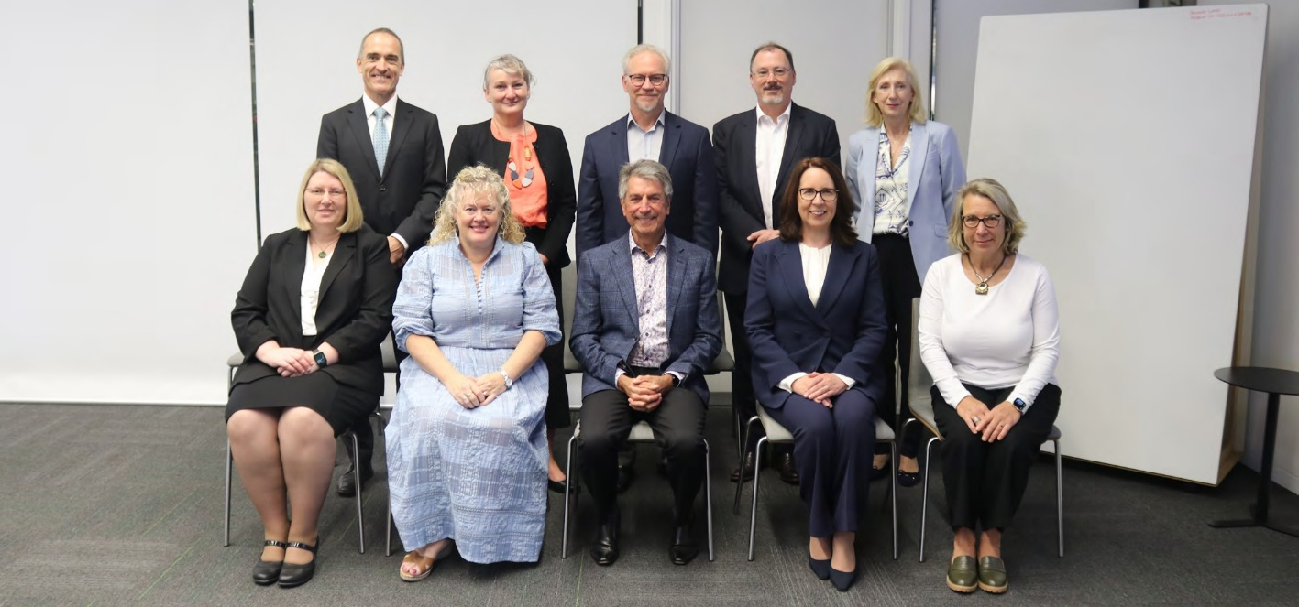
The Association of Information Access Commissioners (the AIAC) gathered in Wellington recently.
Back row (l-r): Sven Bluemmel (Victoria), Joanne Kummrow (Victoria), Wayne Lines (South Australia) Iain Anderson (ACT), Elizabeth Tydd (New South Wales).
Front Row (l-r): Rachael Rangihaeata (Queensland) Bridget Hewson (NZ) Peter Boshier (NZ) Angelene Falk (Australia Federal IC), Catherine Fletcher (Western Australia).

Cook Islands International Learning & Development workshops
Staff from the Office of the Ombudsman recently ran learning and development workshops in the Cook Islands for Ombudsman Cook Island staff. The office plays an important role in the Pacific promoting education, knowledge-sharing and leadership and on the importance of government scrutiny, accountability and transparency.
The office also learns from and benefits from the insights of our Pacific neighbours.
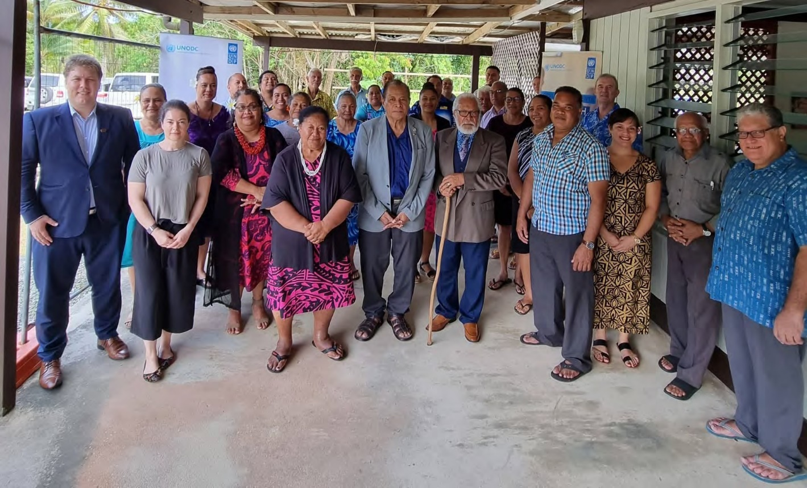
Office of the Ombudsman staff support the United Nations Development Programme Right to Access Information Seminar, hosted in Niue.

Disability rights

Chief Ombudsman discusses disability rights with government ministers
Chief Ombudsman Peter Boshier was recently part of a productive and engaging Ministerial meeting on disability issues.
The biannual Ministerial Leadership Group on Disability Issues (MLGDI) meeting was hosted by then then Minister for Disability Issues, Poto Williams, with nine Ministers in attendance.
MLGDI meetings are an opportunity for the Independent Monitoring Mechanism (IMM) to alert Ministers to concerns and opportunities in the disability sector as part of its monitoring role.
The group discussed a range of issues including the United Nations Committee on the Rights of Persons with Disabilities’ concluding observations, and the government’s plan to respond to and implement these over the coming years. The Chief Ombudsman’s focus was on the opportunities the concluding observations bring to New Zealand as an opportunity to progress disability rights issues that have stagnated.

Ensuring inclusion & accessibility in office documents
An important part of the Chief Ombudsman’s role is ensuring his documentation aligns with the Disability Convention and that he is taking steps to ensure his Office is accessible to disabled people. These efforts seek to ensure the Ombudsman is fully accessible and inclusive to disabled people who contact the office or who want to work there.
To ensure this is achieved, Peter Boshier and his Disability Rights team meets regularly with Te Rōpū Kaiārahi Hauātanga - the Disability Advisory Panel - which reviews some of the office’s documentation.
Most recently, several of the office’s key recruitment policy documents, guides
and forms were reviewed by TRKH which also noted that it was heartening to see how the office’s work towards full inclusion was not just an exercise in box-ticking.
Find out more about Te Rōpū Kaiārahi Hauātanga.

Māori engagement

Waitangi Day 2023
This year’s Waitangi Day held extra special significance for the Chief Ombudsman. It was the first time an Ombudsman had been invited to deliver the dawn service karakia alongside other dignitaries at Te Whare Runanga. Peter Boshier also attended a number of events including a Parliamentary Powhiri at Te Te Whare Runanga, and an engagement with Tai Tokerau leaders.
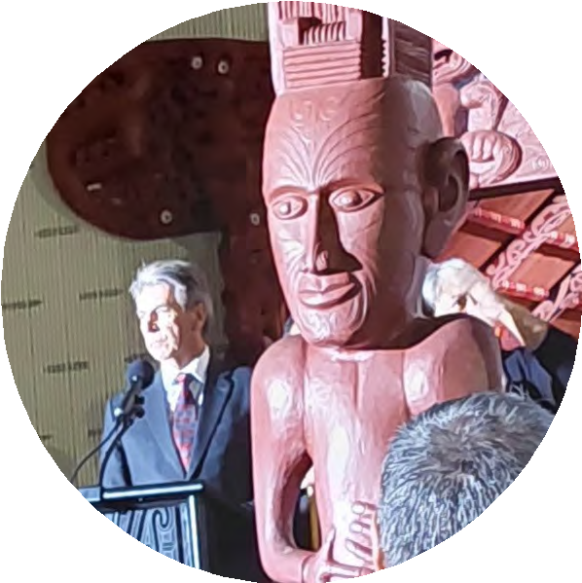
Peter Boshier delivering his dawn service karakia.

Peter Boshier and Dame Naida Glavish, member of the Chief Ombudsman’s Pūhara Mana Tangata (Māori Panel)

Chief Ombudsman meets with Tuhoe senior leaders
The Chief Ombudsman recently met with Ngāi Tūhoe senior leaders in the eastern Bay of Plenty to share information about his role and functions and hear first-hand insights, concerns or matters of interest to Ngāi Tūhoe related to the Ombudsman’s mandate.
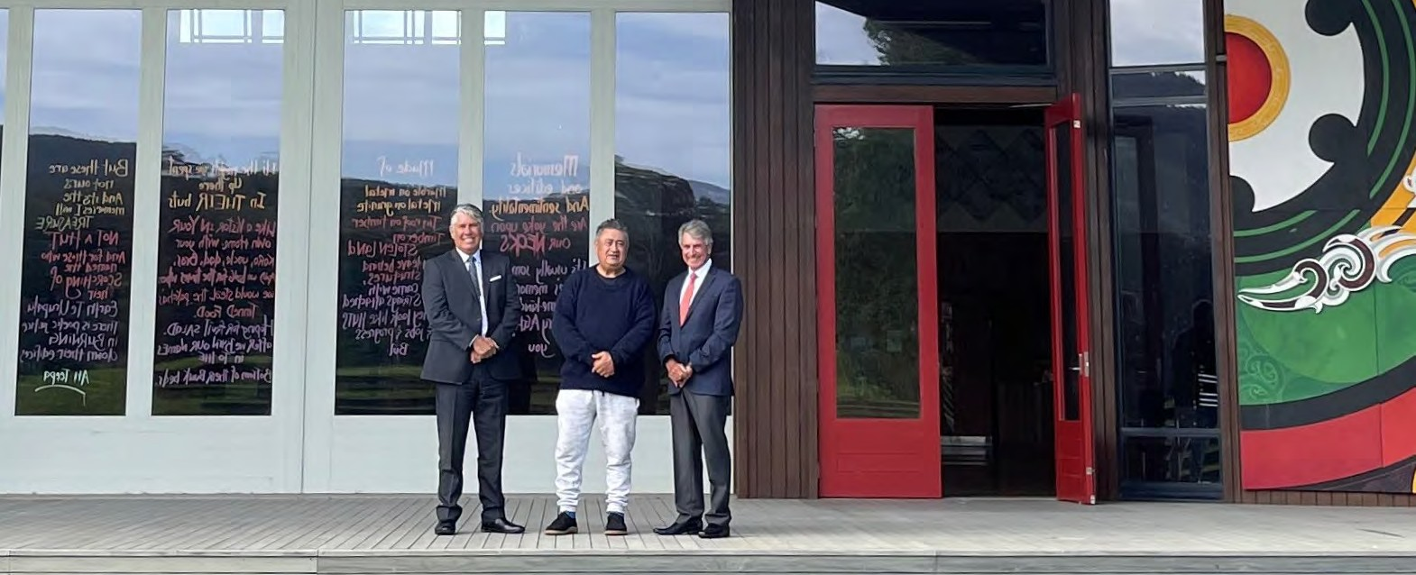
L-R: The Office of the Ombudsman’s Kaiwhakahaere Māori Hononga Hapori Dexter Traill, Tūhoe Te Uru Taumatua chair Tamati Kruger and Chief Ombudsman Peter Boshier at Te Kura Whare in Tāneatua.

Office of the Ombudsman internship programmes

Summer interns farewelled
Peter Boshier has farewelled the five student interns he hosted as part of his Summer Internship Programme for 2022.
The latest intake of interns were a mix of tertiary and post-graduate students who were placed in various teams, including the Strategic Advice Team and the Intake and Early Assistance Team to enable them to get to know more about the Ombudsman's work.
The Chief Ombudsman also runs an internship programme in partnership with Kiingitanga. This is now in its third year and continues to highlight the strong and important collaborative relationship the Chief Ombudsman has with the Kiingitanga. The Kiingitanga Intern has been working in the area of Māori and Community Outreach and Engagement, whilst also experiencing working with the Kiingitanga and Pūhara Mana Tangata.
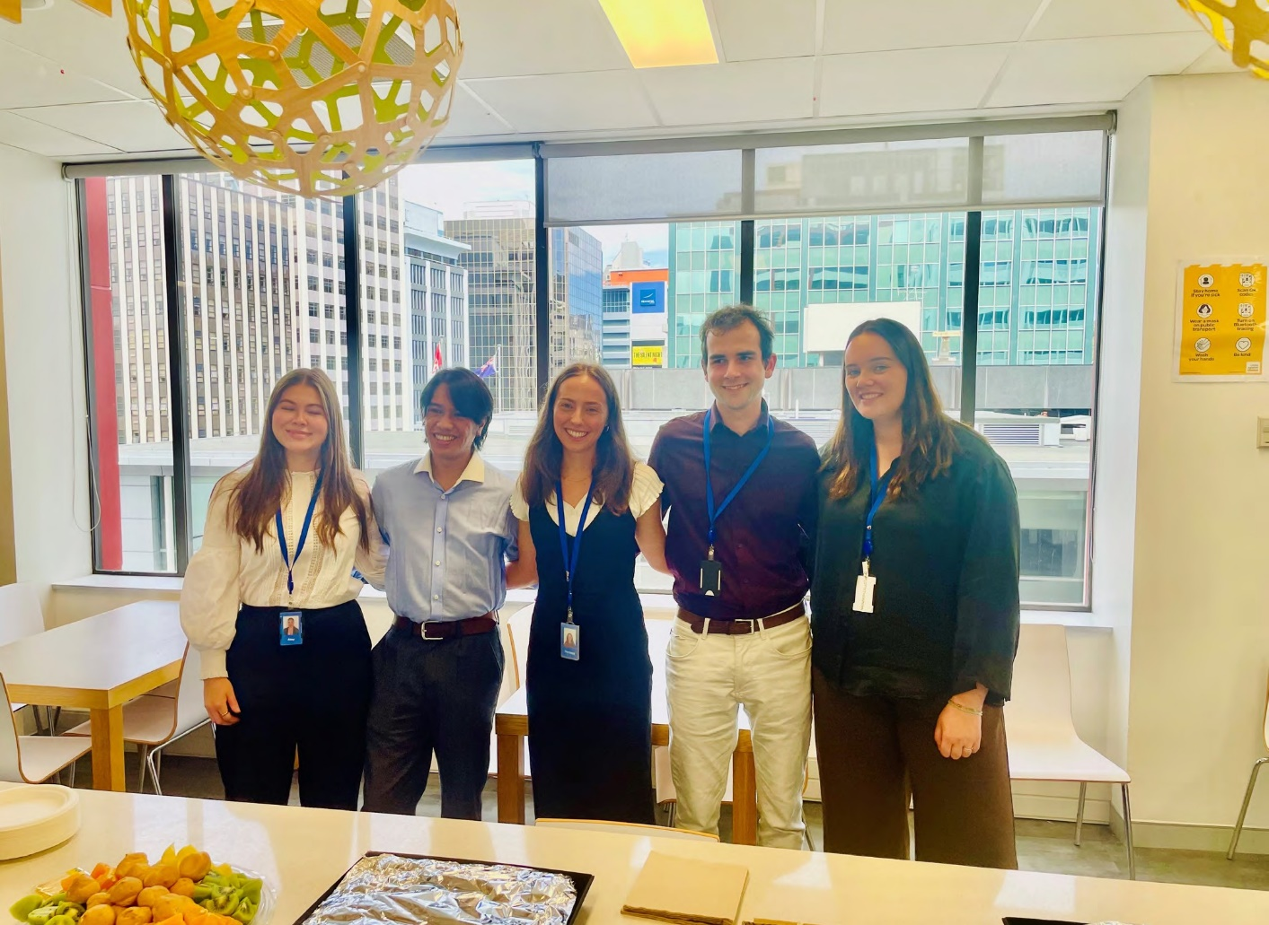
Office of the Ombudsman interns (l-r): Amy, Miguel, Florence, Kylen and Charlotte.

Te Kaitiaki Mana Tangata Aotearoa
The Ombudsman New Zealand
Contact us: 0800 802 602 or info@ombudsman.parliament.nz
Find out more: ombudsman.parliament.nz
Follow us: facebook.com/ombudsmannz
Previous issues: ombudsman.parliament.nz/resources
Get OQR emailed: ombudsman.parliament.nz/about/subscribe

